AUCTION NOTICE
The Management of AGS Rwanda Ltd hereby informs the general public that a public auction will be conducted for various assets belonging to the international organization WCS, as well as other items belonging to private individuals.
All items offered for sale are used items and will be sold on an "as-is, where-is" basis.
LIST OF VEHICLES OF THE WCS IS AS FOLLOWS BELOW :
- PICK-UP RAE - 506J
- JEEP TOYOTA /L/C: HARDTOP - RAD 816 W
- PICK-UP TOYOTA HILLUX - RAE 814J
- MOTORCYCLE - RE 974 R
LIST OF ITEMS FROM PRIVATE OWNERS:
- Camera canon  - Frigot  - Congelateur  - Matora  - Amatapee  - Intebe zo muri salon  - Printer  - Television  - Computer  - Laptop  - Amatara abajour  - Ibikoresho bya sauna  - Projector Epson  - Amapasi y’umwuka dukoresha muri dry cleaner | - Cafetiaire nziza cyane  - Cuisiniaire  - Imachine ikora block cimant  - Ibikoresho by’ubwubatsi,  - Amaforeze  - imachine zoza ibikuta, imachine automatique zisohora amafoto nyuma y’iminota 5  - Amacamera afotora y’ubwoko bwinshi  - Ububati  - Office chair  - Amatara akubiyemo ventilateur  - Amamatela y’umugongo  - Sofa  - Ibyuma bituraga amagi  - N’ibindi byinshi, muze mwirebere.

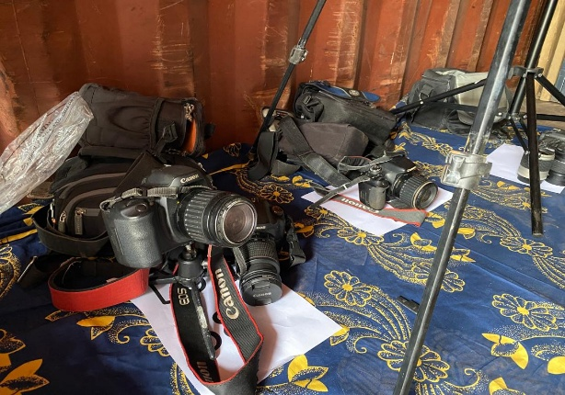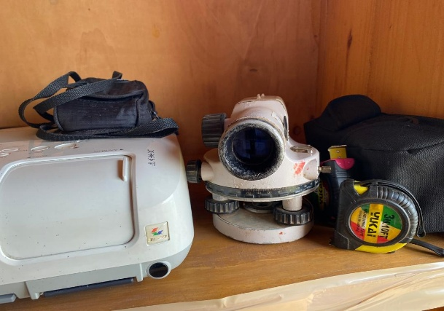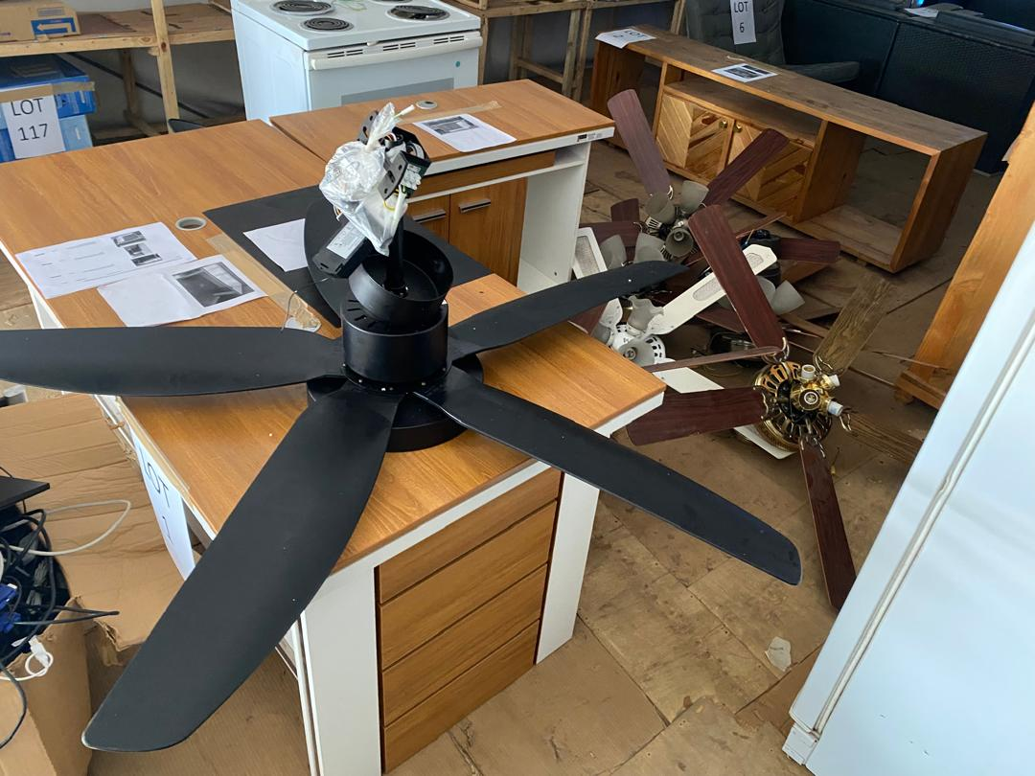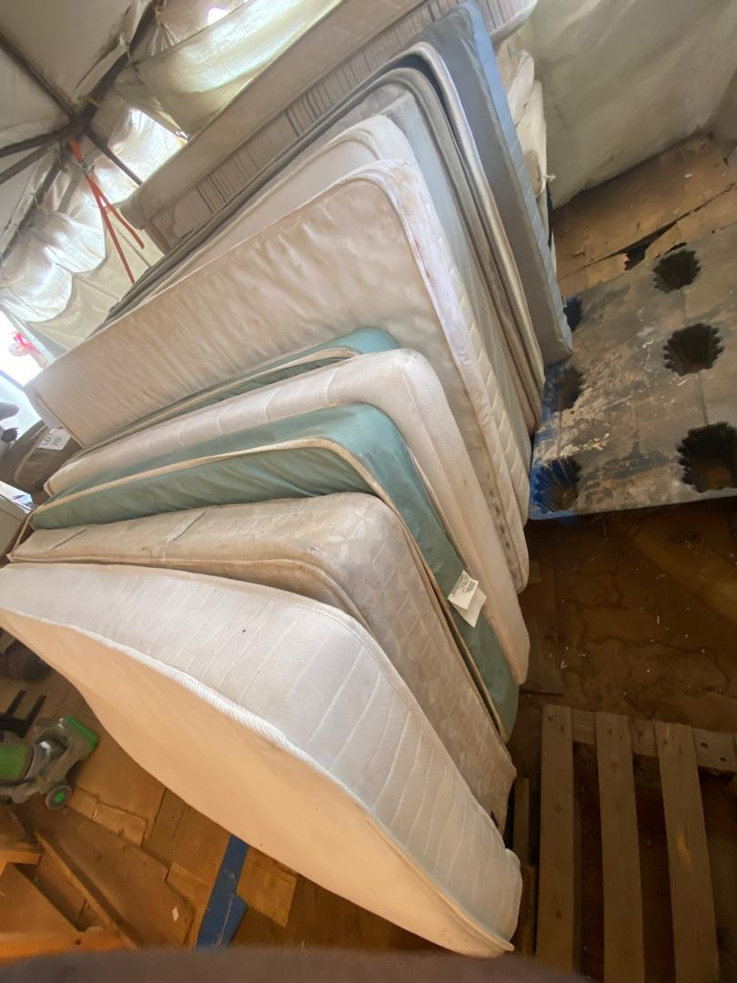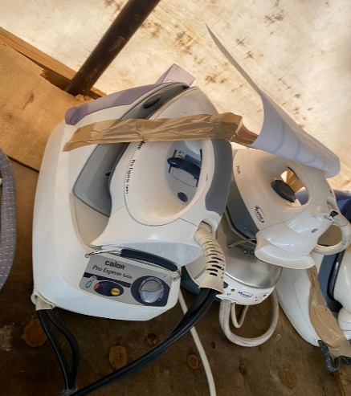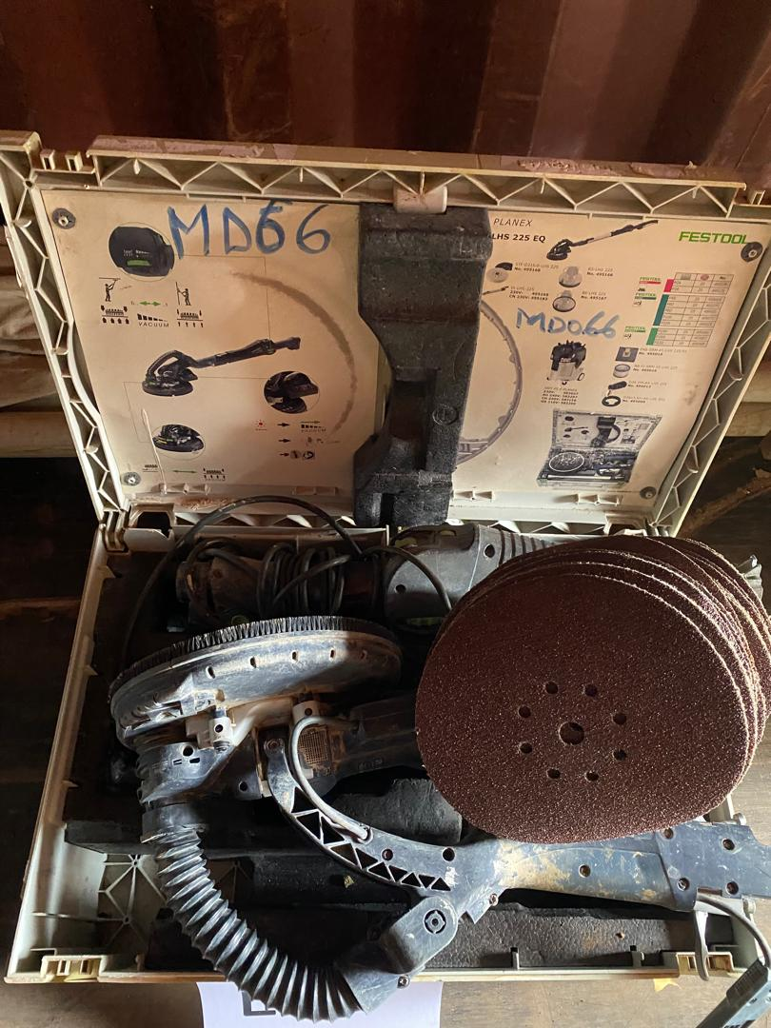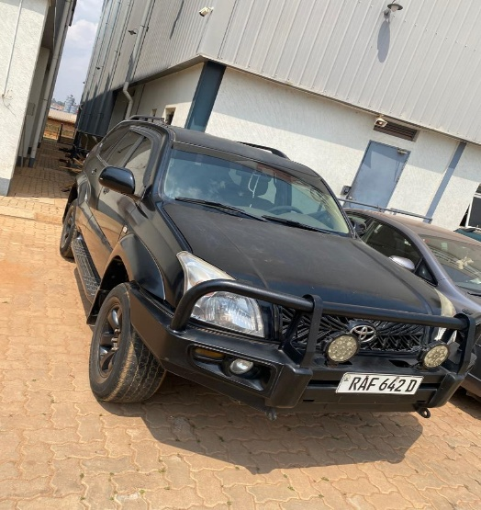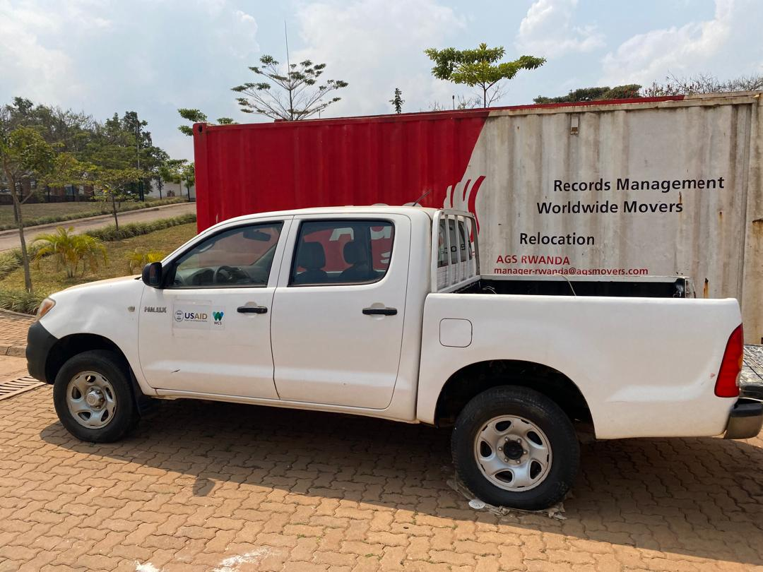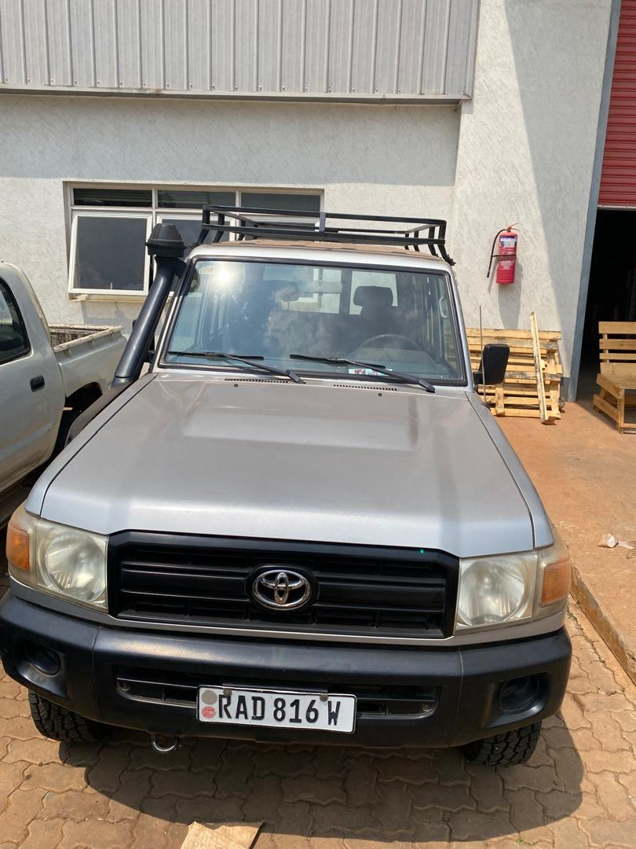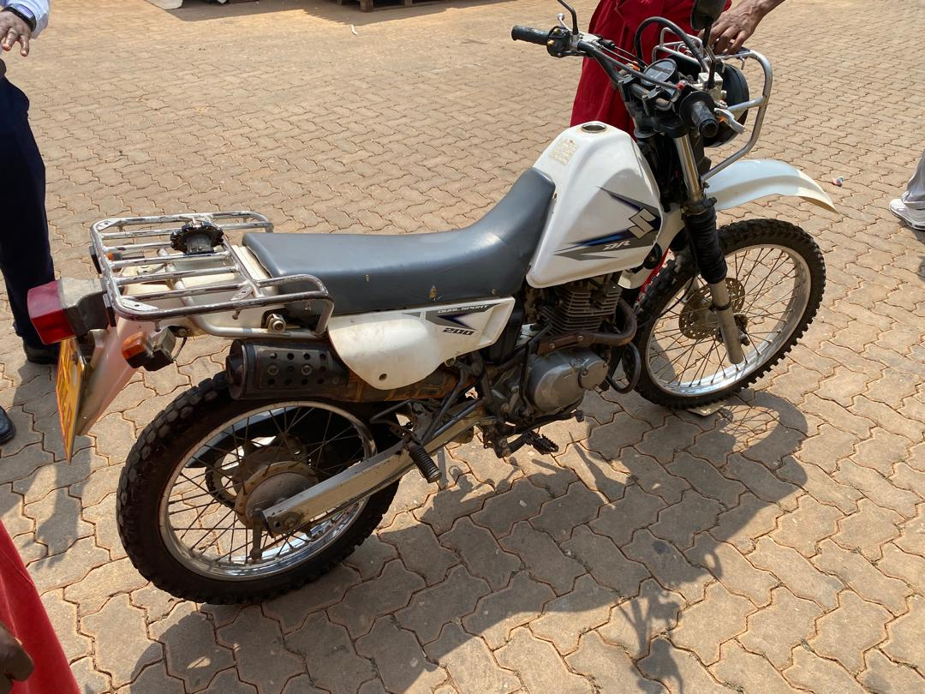

Auction Date and Venue
The auction will take place on Thursday, July 30, 2026, starting at 10:00 AM at AGS Rwanda Ltd, located at PEZ Phase II, D16, Kigali.
Registration Fee
All participants are required to pay a non-refundable registration fee of RWF 10,000 to: MoMo Code: 046582 – AGS Rwanda

Security Deposit for Vehicle and Motorcycle Bidders
Anyone wishing to bid on vehicles or motorcycles must provide a security deposit of RWF 2,000,000 through the AGS Rwanda MoMo Code or submit a certified cheque. The deposit will be refunded to unsuccessful bidders.
Payment Terms for Successful Bidders
The successful bidder for any vehicle or motorcycle shall: Pay 30% of the winning bid amount on the auction day; and pay the remaining 70% within three (3) days. Vehicles and motorcycles will only be released after full payment has been received.
Visiting of Items
Interested buyers may visit the items from Monday, July 20, 2026, to Thursday, July 29, 2026.For further information, please contact:
Simon Mweni, Email: simon.mweni@ags-globalsolutions.com Telephone: +250 788 485 588
Important Notice
Successful bidders must collect their purchased lot on the following day and present proof of payment to the Depot Manager before the items can be released.

Done at Kigali on July 20, 2026.
AGS Rwanda Management

