Technical specifications and technical and timetable offer

Publication reference : RWA/TES/SE02
Subject : Framework contract for the acquisition of sports Equipment

Column 1: to be completed by PLAY International, detailing the technical characteristics requested (not to be modified)
Column 2: to be completed by the tenderer. Must detail the offer

Where applicable, tenderers must clearly indicate which options are included.
Tenderers must clearly indicate any additional documents added to their technical proposal.
Tenderers must provide a sample or a catalogue of the equipment proposed in their tender in the language of this dossier, or a combination of the two.
Tenders that do not precisely identify the models and specifications of the equipment may be rejected by the evaluation committee.
Bids must be precise so that PLAY International can easily compare the proposals received.

 | 1 -TECHNICAL SPECIFICATIONS  RECOMMENDED BY THE BUYER |  |  | 2 - TECHNICAL SPECIFICATIONS AND LEAD TIMES  OFFERED BY THE SUPPLIER
No | Description of Supplies | Photo | Unit of measurement | Description of Supplies | Quantity | Unit of measurement | Delivery time (expressed in days from the date of signature of the contract)
1 | Adidas F50 League Firm/Multi-Ground Boots  Quantity: 340  for children aged 12 to 15, Sizes EU 36–43 (UK 3.5–8.5 / US 4–9.5)  Size EU (40-43) = 70%  Size EU (36-39)= 30% | 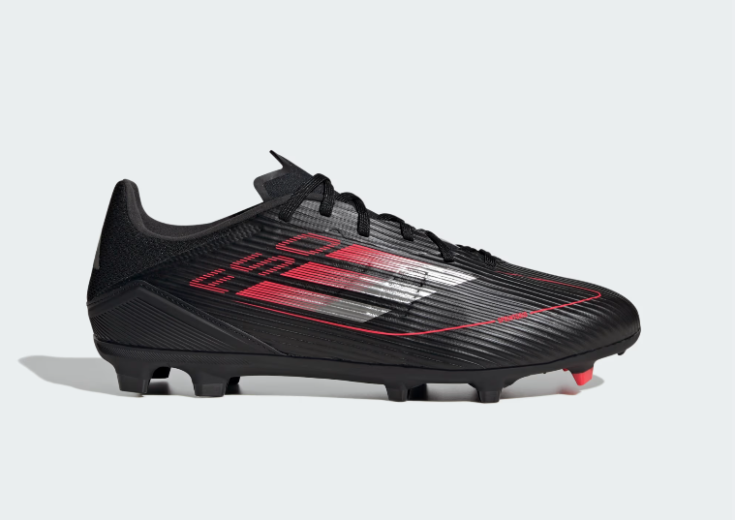 | Paires

